

Dear Residents,

Roadstone Ltd is working on behalf of the Transport Infrastructure Ireland & Dún Laoghaire-Rathdown County Council on the N11 and N31 Pavement Renewal Scheme – Phase 2. The works will take place on the following roads:

* N11 Stillorgan Road Between the R825 Lower Kilmacud Road to the Bray Road Junction.

1. **Works Duration for Project:**

Works Duration for project will be approximately 3 months.

1. **Details of works from Tuesday the 11th April 2023 to June 2023:**

|  |
| --- |
| **N11 Stillorgan Road Between the R825 Lower Kilmacud Road to the Bray Road Junction.**  **Night Works – Resurfacing works**  Date – Tuesday the 11th April 2023 to Friday the 2nd June 2023.  Time - Monday to Friday – 19.30hrs to 05.30hrs.  Traffic management Description - Night-time – Road Closure  Work Description - Milling works, Preparing Road, Resurfacing Road, Resetting Ironworks & relining road markings on road.  Road closure on the N11 will be broken up into 6 sections and will be completed in order from 1 to 6.   1. Lower Kilmacud Road to Newtownpark Avenue junction Southbound. 2. Lower Kilmacud Road to Newtownpark Avenue junction Northbound. 3. Newtownpark Avenue to Kill Lane junction Southbound. 4. Newtownpark Avenue to Kill Lane junction Northbound. 5. Kill Lane Junction to Bray Road junction Southbound. 6. Kill Lane Junction to Bray Road Junction Northbound.   **Night Works – Civil works**  Date – Wednesday the 19th April 2023 to Friday the 30th June 2023.  Time - Monday to Friday – 19.30hrs to 05.30hrs.  Traffic management Description – Lane Closures.  Work Description: Laying High Friction Surfacing, raising iron works, reinstalling traffic loops.  When working on the N11 there will be barriers across entrances to block the works area. If you require to get in & out, please ring Traffic management emergency contact below. There will also be an operative floating to open and close Barriers. Roadstone Ltd will however endeavour to keep noise and delays to a minimum. In the event of unforeseen circumstances dates of works may vary Slightly. We apologise in advance for any inconvenience that this may cause. **Note:** **Diversion routes and weekly updates of works will be posted on the Web Page.** |

1. **Scheme Extents**

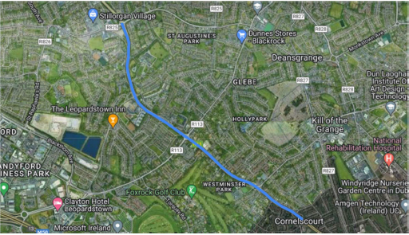

**Figure 1 Scheme Extents**

1. **Project Updates**

Project updates and Weekly letters of where works will be taking place will be posted on Web Page. Please see link below to web page:

<https://roadstone.ie/n11-phase-2>

1. **Contact details For Project**

Graham Doyle (Roadstone Ltd) – 0872792090 [gdoyle@roadstone.ie](mailto:gdoyle@roadstone.ie)

Robert Delahunty (Roadstone Ltd) – 087 1707789 [rdelahunty@roadstone.ie](mailto:rdelahunty@roadstone.ie)

Darren Jordan (Roadstone Ltd) – 0871727123[djordan@roadstone.ie](mailto:djordan@roadstone.ie) (Liaison officer)

**Traffic management emergency contacts**

**Emergency number day or night: 087 272 2276**