

Dear Residents,

Roadstone Ltd is working on behalf of the Transport Infrastructure Ireland & Dún Laoghaire-Rathdown County Council on the N11 Pavement Renewal Scheme Phase 2. The works will take place on the following location:

* N11 Stillorgan Road Between the R825 Lower Kilmacud Road Junction to the Bray Road.

1. **Works Duration for Project:**

Works Duration for project will be approximately 6 months.

1. **Details of works from Tuesday the 10th January to June 2023:**

|  |
| --- |
| * **Works Location – N11 Stillorgan Road Between the R825 Lower Kilmacud Road Junction to the Bray Road Junction.**   **Day time and night-time works**  Date – Tuesday the 10th of January 2023 to Friday the 31st of March 2023.  Time - Monday to Friday – 10.00hrs to 16.00hrs  Time - Monday to Friday – 19.30hrs to 06.00hrs  Time - Monday to Friday – 08.00hrs to 18.00hrs  Traffic management Description N11 – Lane Closures on Lane 1 and 2, Stop & go and 24hr bus lane closures required for certain phases of works. Section of footpaths and cycle lanes will be closed for short duration to complete works.  Work Description: GPR works and Civil Works to repair sections of footpath, cycleway, sections of kerbs and drainage works.  When working on the N11 there will be barriers across entrances to block the works area. If you require to get in & out, please ring Traffic management emergency contact below. There will also be an operative floating to open and close Barriers. Roadstone Ltd will however endeavour to keep noise and delays to a minimum. In the event of unforeseen circumstances dates of works may vary Slightly. We apologise in advance for any inconvenience that this may cause. **Note:** **Diversion routes will be posted on Web Page.** |

1. **Scheme Extents**

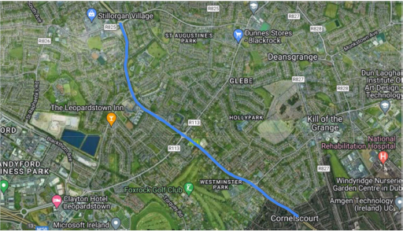

**Figure 1 Scheme Extents**

1. **Project Updates**

Project updates and Weekly letters of working times and where works will be taking place will be posted on Web Page. Please see link below to web page:

<https://www.roadstone.ie/n11-phase-2/>

1. **Contact details For Project**

Graham Doyle (Roadstone Ltd) – 0872792090 [gdoyle@roadstone.ie](mailto:gdoyle@roadstone.ie)

Robert Delahunty (Roadstone Ltd) – 0871707789 [rdelahunty@roadstone.ie](mailto:rdelahunty@roadstone.ie)

Darren Jordan (Roadstone Ltd) – 0871727123[djordan@roadstone.ie](mailto:djordan@roadstone.ie) (Liaison officer)

**Traffic management emergency contacts**

**Emergency number day or night: 087 272 2276**